Presentation and layout = css

Cascading style sheet = css

Font color , size etc

Layout = placement.

Html vs css :

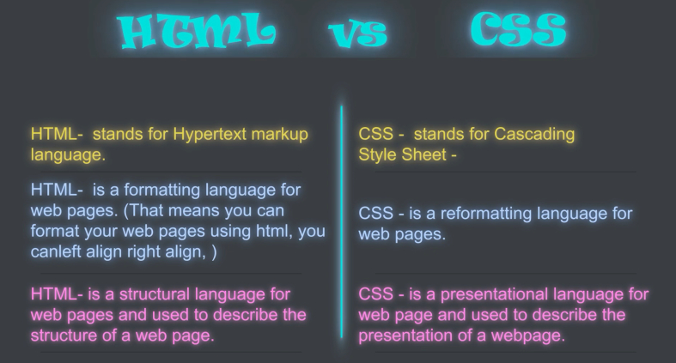

Css describe how elements used to be displayed beautifully and attractive



We can style a skeleton into a content which can be visualized in terms of colors gradients placements and designs



Add borders , specify width and height , color size etc

Selector is paragraph declaraction is color name

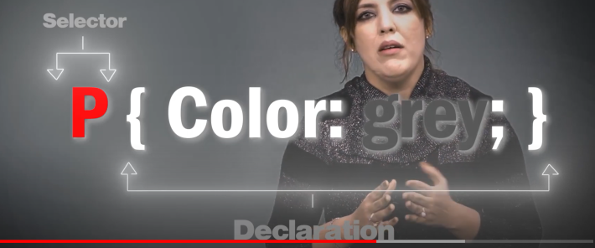



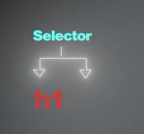

Applying styles in multiple elements

Adding a color in heading:

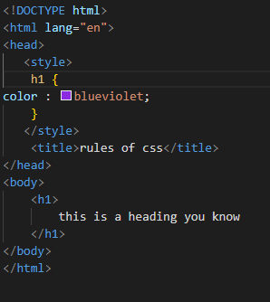

Adding multiple headings with same color :

Changing fonts

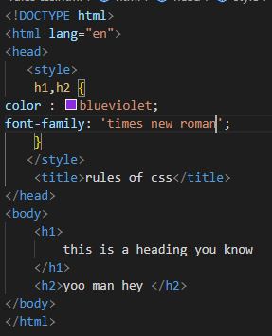

There are two types of css inline css and internal css

Inline css = css including into html code file.

Internal css means linking separate css code file with html source file.

***Inline css:***

Styles used only single elements.



Three types of css we can apply.

Inline css

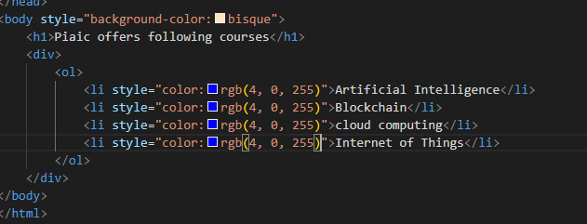

External css

Internal css

***Internal and embedded css:***

Written in head tag.

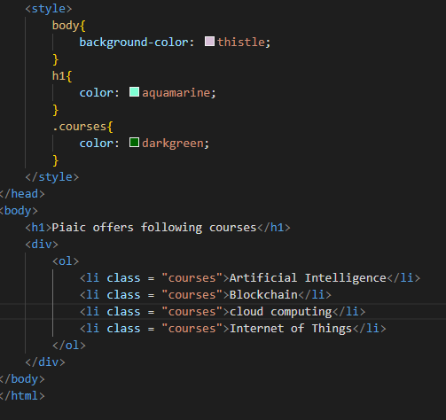

***External css:***



Specity file name with .css extension.

Text css we use with hyptertex reference.

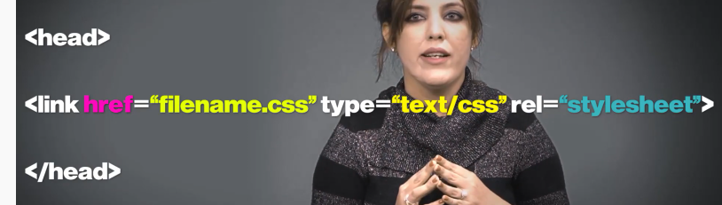

Fonts and colors and external stylesheet for that we use which can be applicable on all pages using just one stylesheet file.

***Css Selectors:***

*(universal selector) all elements on the page targets.applying same rule on the whole page.

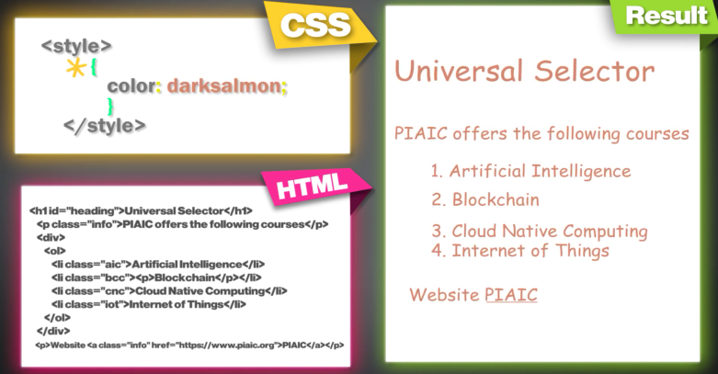

,(type selector) element selector by giving element name.

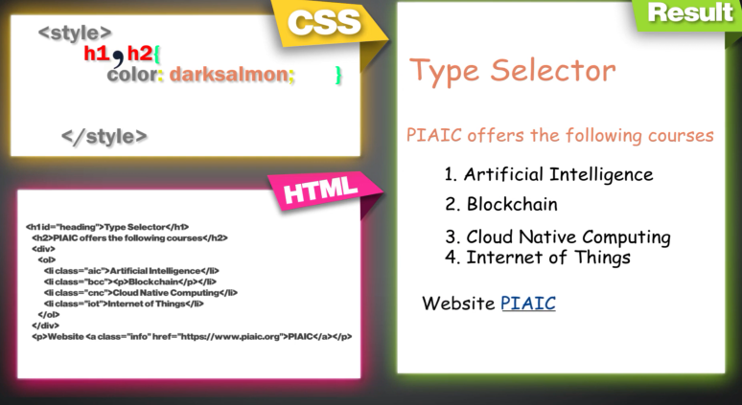

.(class selector) selects elements with specific class attributes.

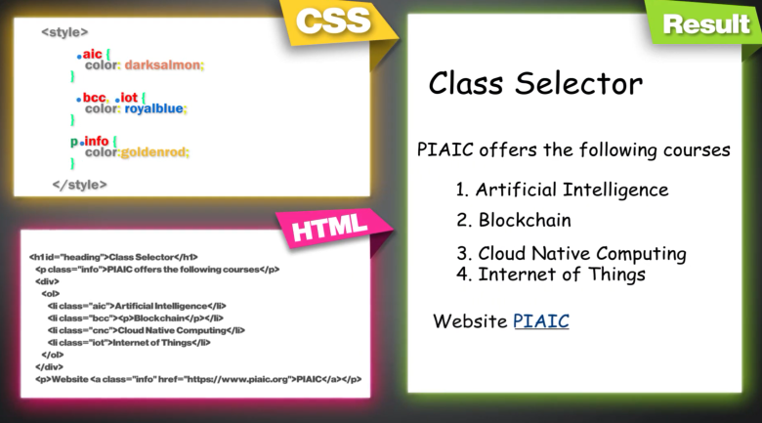

#(id selector)

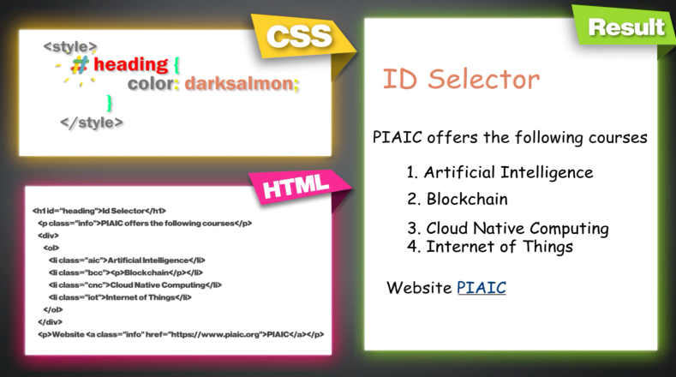

>(child selector)

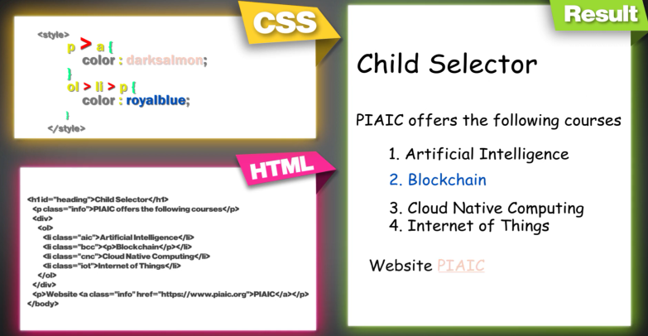

<->(decendent selector)

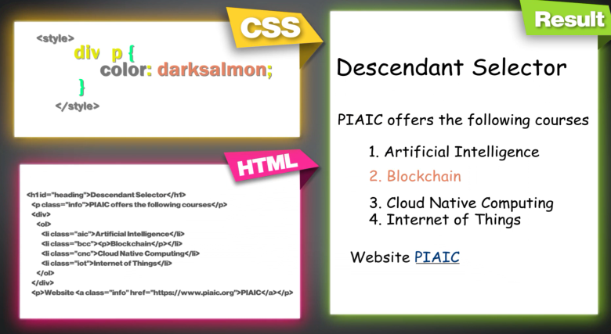

+(adjacent sibling selector) matches the element that is the next sibling of another.

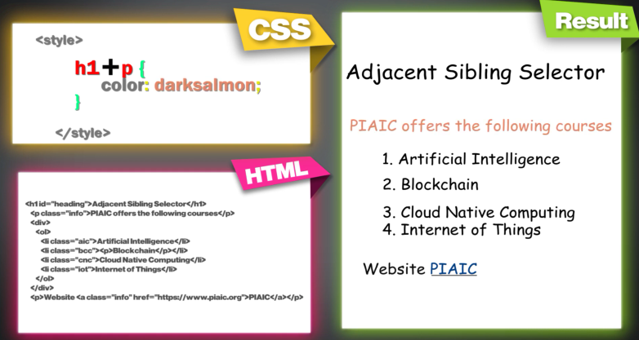

~(general sibling selector)

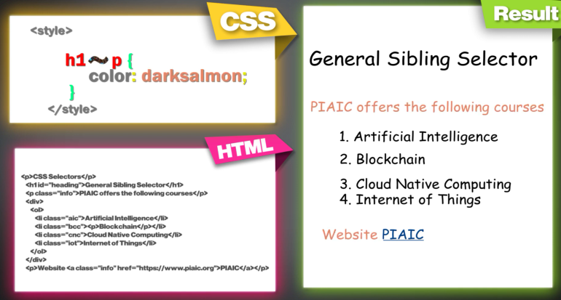

Responsiveness:

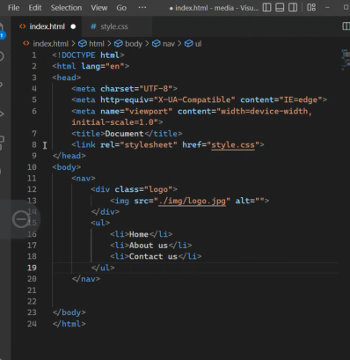

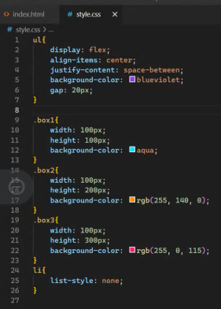

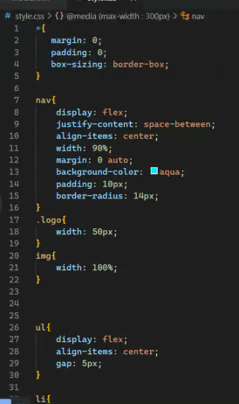

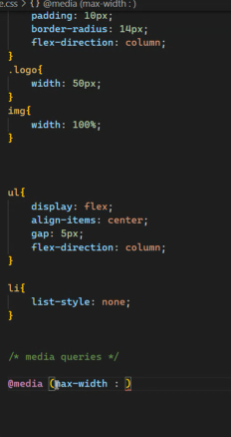``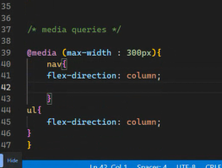

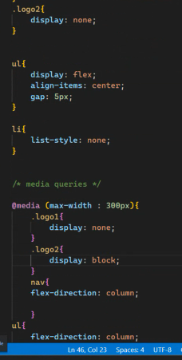

Checking and adding different mobile types dimensions into media queries

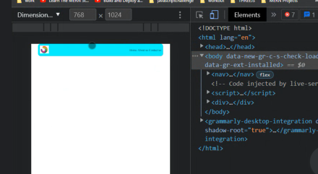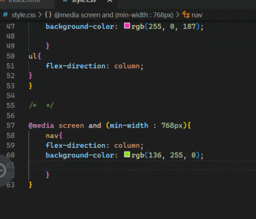

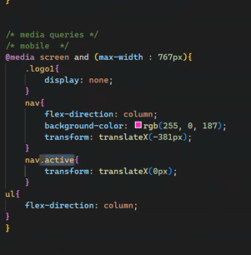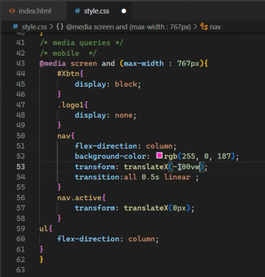

Example 02 :

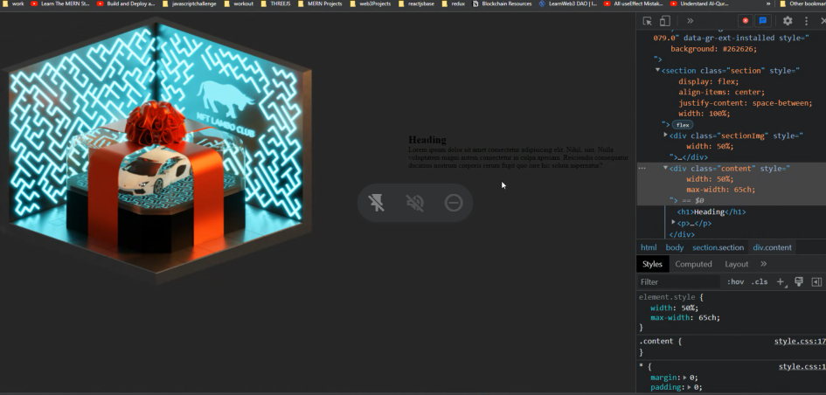

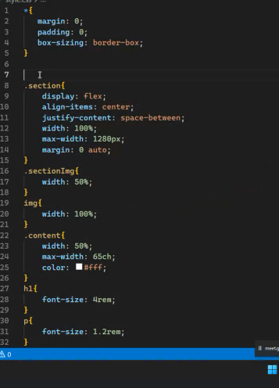

***HTML FILE FOR SELECTORS :***

***Universal selector :***

***Type selector :***

***Type selector :***

***ID selector :***

Id remains unique for each page.

***Child selector :***

For instance target div tags for styling whose parent is div. any elements just associated with div.

Changes applied only those elements whomes are the child of parent “div”.

Target to direct child.

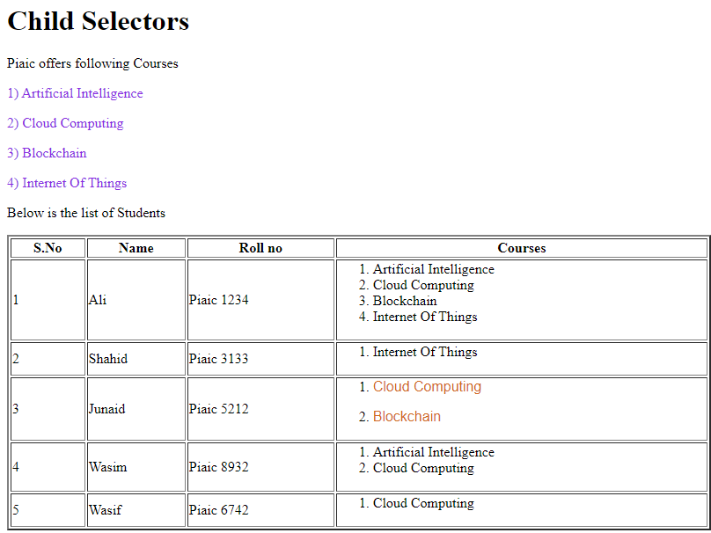

***Decendent selector :***

No matter child is direct or indirect.

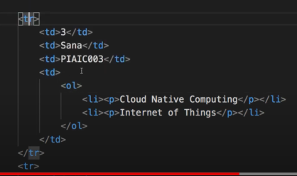

Since there are many elements of childs and parents to each other.

Targeting specific para form many paras already there of same child.

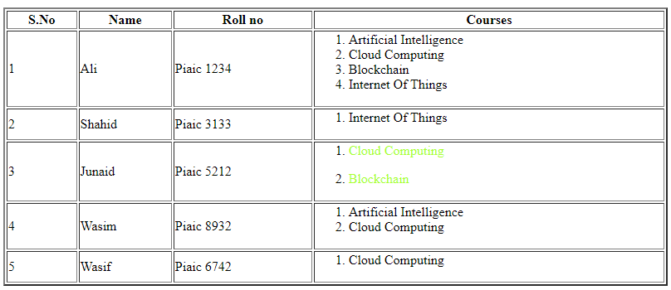

***Targetting sibling selector :***

Adjacent sibling , targets nearest sibling of first heading or element.

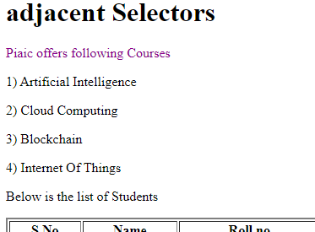

***General sibling selector :***

Same level elements just targeted.

H1’s general siblings are targeted like h2 h3 h4

Paras before h1 is ignored.

Targeting all div elements.

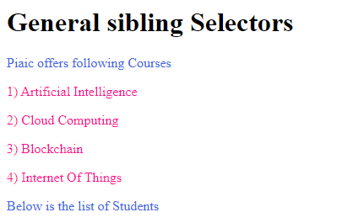

General Practice Examples :

There is rule to override to the past changes in css sytles. Use !important there.

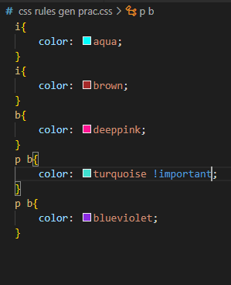

***Inheritance:***

Properties applied on parent to child , fetching data and properties of one parent to another child like fetching same color from some element to other elements etc.

Padding is used to give spaces from every side.

Every para have the same distance for instance 10 px from each other.

***Science of colors:***

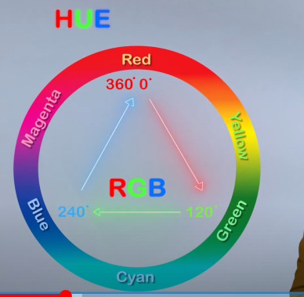

***Color property:***

There are three ways to specify color of elements:

* Give color name
* Rgb
* Hexcode
* Color names

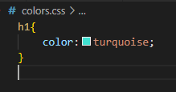

…………………………………………………………….x…………………..x……………………….

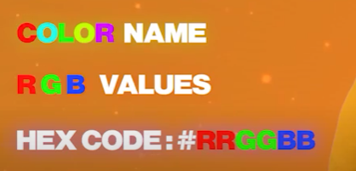

147 predefined color names.

RGB:

Mixing three colors to make new colors of our choice.

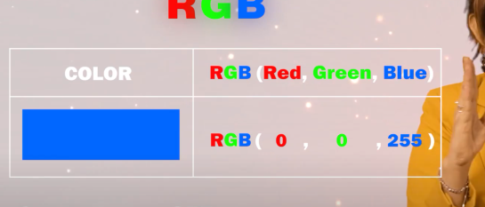

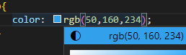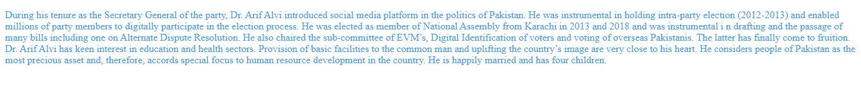

Hex code :

6 digit code. 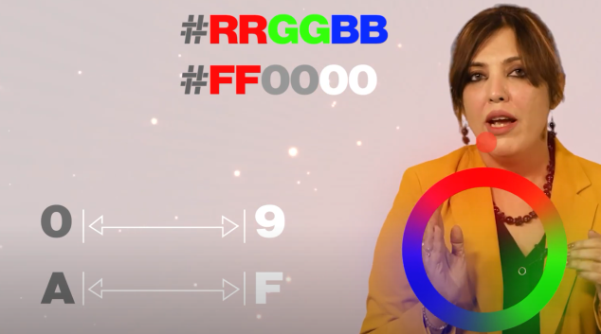

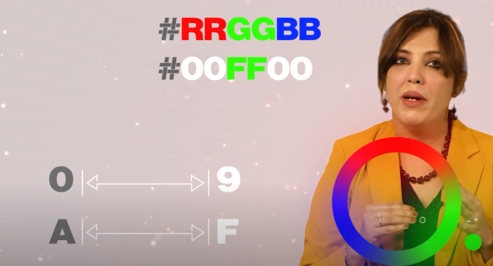



Working on border and background color:

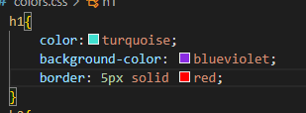



Transparency how solid an element img or text looks.

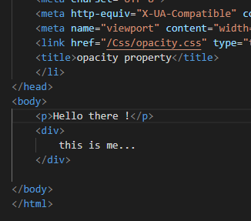

Example 02 :

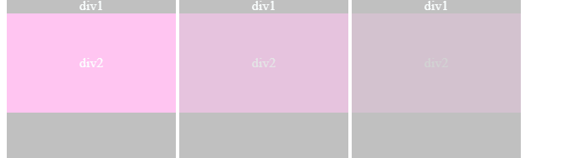

***RGBA:***

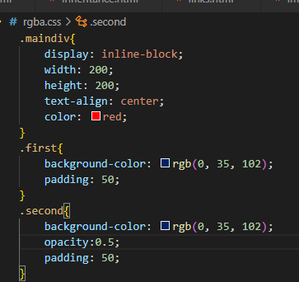***

Since the child of the div1 which is div2 is also makes itself transparent although we just want background to be transparent.

For that see below code:

For that we use alpha property.

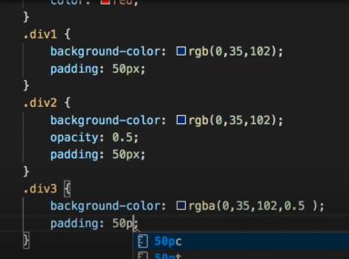

***Padding:***

Highlighting area radius:

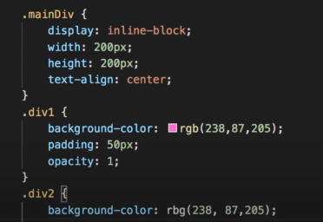

***HSL HSLA:***

Hsl = hue saturation lightness

Hsla = hue saturation lightness alpha

Alpha = fully transparent , fully opaque.

Hue can also we be shown as a slider.

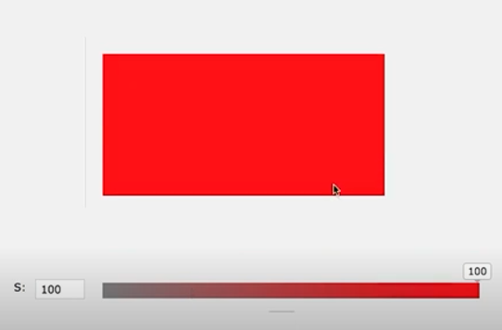

Hui 0 = fully transparent

Hui 1 = fully opaque.

Alpha = opacity.

H = transperancy

S = color change

L = dark or light color

A = visibility

***Borders and backgrounds:***

Border radius = round border edges

Border width = thicker or thiner the boders from all four sides.

Border style = transparent , solid etc.

Example 1:

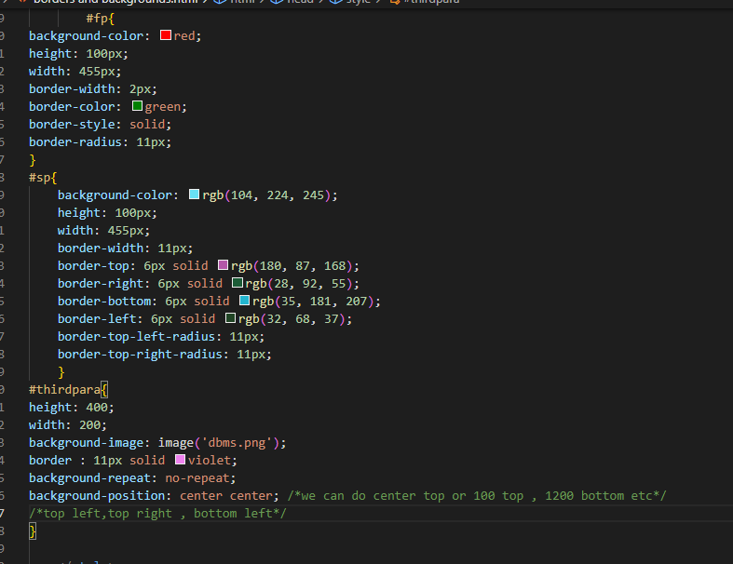

Output:

***Box model margin padding:***

Box model

